## Abstract

Papua New Guinea has high levels of STIs, and relatively high levels of HIV. Some STIs, especially the ulcerating STIs syphilis and herpes simplex virus 2 (HSV2), increase the odds of transmitting or receiving HIV. Periodic presumptive treatment (PPT) for some of these STIs is a possibility one reducing many STIs, including syphilis. Any reduction in syphilis will cause a reduction in HIV transmission and susceptibility, and thus reduce the number of new cases of HIV (incidence of HIV). Thus, PPT may be able to reduce HIV incidence.

We build a simple model for syphilis in Papua New Guinea to model the effects of PPT on syphilis. We use an existing model (Gray et al., 2010) to model the effect on HIV of such a decrease in syphilis. Our model has three main outputs: decrease in syphilis prevalence, decrease in HIV incidence, and time taken for 50% of the intervention’s effect on syphilis to happen.

## Definitions

|  |  |
| --- | --- |
| Term or abbreviation | Definition |
| FSW | Female sex workers |
| MSMW | Men who have sex with men and women |
| Incidence (of a disease per unit time) | Number of new cases of that disease in that time |
| Prevalence (of a disease) | Proportion of people who have that disease |
| PNG | Papua New Guinea |
| Sub-populations | General males, MSMW, general females and FSW |

## HIV model

For our model of HIV, we use the model from Gray et. al., 2010, with some modifications. This model uses the period from 1990 to 2010 as a calibration period, then predicts HIV levels under various intervention strategies.

Since 2010, new data has become available, causing us to revise some parameters into line with current research. In particular, as HIV clinics have spread into more areas, lower levels of HIV have been discovered. Previously, many people would have travelled to reach clinics, and would have been more likely to make the trip if they suspected they were infected. We take the view that rather than being due to a decrease in HIV, this is due to clinics in a broader part of the community having had a lower level of bias. Previously, data from heavily-affected regions was extrapolated across the country, and we take the view that this has been found to be an over-estimate. We have also found that the STI cofactor used in the model was at the top of its confidence band. We have re-fitted the model to a lower STI cofactor.

We have achieved this by varying the baseline transmission probabilities, average numbers of sex acts per partner and diagnosis and treatment rates for people with HIV.

The model accounts for STIs by allowing the user to specify a single time series of prevalences of ulcerating STIs for each sub-population. The model increases the HIV transmission probability by a cofactor if either partner has an STI. This prevalence of ulcerating STIs is held constant during the calibration, then allowed to vary during the intervention.

One major ulcerating STI in PNG is syphilis. Syphilis is caused by a bacterium, Treponema pallidum pallidum, and as such is vulnerable to certain antibiotics including penicillin G benzathine and azithromycin. The other major ulcerating STI, HSV-2, is caused by a virus and is not vulnerable to antibiotics. To model the effect of a PPT program for syphilis, we build a simple SIRS model for syphilis, ignoring the effects of PPT on other ulcerating STIs, and ignoring any effect of HIV on syphilis transmission. By assuming independence between syphilis and other ulcerating STIs, and estimating the fraction of people with ulcerating STIs who have syphilis, we can also estimate the level of syphilis used in calibrating the HIV model. We can then calibrate our syphilis model to the syphilis level in the HIV model. We run our syphilis model for a variety of interventions and a variety of assumptions about the relative prevalence of syphilis among people with ulcerating STIs, then calculate the corresponding STI levels. We input these into the HIV model as interventions, and thus predict the effect of our syphilis PPT on HIV transmission.

## Baseline syphilis levels

We take the proportions of each sub-population which have ulcerating STIs from the HIV model specifications. We then assume that a certain fraction of the people with ulcerating STIs have syphilis. We allow a person to have more than one ulcerating STI, and assume that having syphilis is independent of having other ulcerating STIs. We calculate the assumed equilibrium syphilis and other ulcerating STI levels from the overall ulcerating STI level as follows:

|  |  |  |  |
| --- | --- | --- | --- |
| Sub-population |  |  |  |
| Assumed proportion infected with syphilis assuming no PPT | Overall level of ulcerating STIs assuming no PPT | Level of ulcerating STIs other than syphilis assuming no PPT |
| Rural FSW | 0.2144 | 0.32 | 0.1344 |
| Rural general females | 0.0603 | 0.09 | 0.0316 |
| Rural general males | 0.0469 | 0.08 | 0.0242 |
| Rural MSMW | 0.0536 | 0.07 | 0.0279 |
| Urban FSW | 0.0335 | 0.05 | 0.0171 |
| Urban general females | 0.0402 | 0.06 | 0.0206 |
| Urban general males | 0.0469 | 0.07 | 0.0242 |
| Urban MSMW | 0.2010 | 0.30 | 0.1239 |

|  |  |  |
| --- | --- | --- |
|  | Fraction of FSWs with ulcerating STIs who have syphilis | 0.67 |

## Syphilis model

### General description

We have built a deterministic compartmental SIS-SIRS model in discrete time. We run two instances of our model per scenario, one for each region as defined by the HIV model, and we do not allow interaction between regions in our syphilis model. We split the population into four sub-populations: general males, men who have sex with men and women (MSMW), general females, and female sex workers (FSW). At any time step , a member of any population can be either susceptible or infected. If that population is undergoing PPT, that member may also be in an additional state, resistant to syphilis due to PPT. Our model contains a set of dependent parameters which allow us to calibrate our model in the no-intervention case to the levels already in use in the HIV model. Since no population is undergoing PPT in the no-intervention case, so every population contains only susceptible and infected members, we only require four dependant parameters to specify our equilibrium.

### Equations for FSW

Our model uses a system of difference equations for the proportions of each sub-population that are susceptible, infected or resistant. These equations are identical between FSW, general females and general males varying only by subscripts, and are only slightly different for MSMW.

The equations for FSW are:

We provide a diagram of the possible state changes, and describe the physical meaning of each state change, in the Appendix. These equations use the following parameters:

|  |  |  |
| --- | --- | --- |
| Parameter | Description | Typical value[1] |
|  | Proportion of FSW who are susceptible | 0.7809 |
|  | Proportion of FSW who are infected | 0.2128 |
|  | Proportion of FSW who have acquired resistance because of presumptive treatment (see note) | 0.0063 |
|  | Infection rate for FSW (see below) | 0.0109 |
|  | PPT rate for FSW (as adjusted, see below) | 0.0078 |
|  | Treatment and loss parameter | 1.2 |
|  | Time step | 1/122 |

We assume that everyone who receives PPT in the time step receives it at the start of that time step. We let contain only the people who have received PPT in this time step, not people who receive any other type of treatment for syphilis. We assume that people who leave immediately become susceptible again.

We also set the length of each time step equal to the duration of protection granted by the PPT, which we assume to be constant. Thus, every person in loses their resistance at the same time, at . We assume that no-one receives PPT immediately after they lose their resistance, so they become susceptible immediately after time . They then have the same probabilities of remaining susceptible or becoming infected by time as the rest of the susceptible people at time , except that the people who were resistant at time have no probability of becoming resistant at time .

The PPT rate is defined as follows:

|  |  |  |
| --- | --- | --- |
|  | Coverage of PPT | 0.75 |
|  | Average number of visits per year, for a person on PPT | 4 |
|  | Initial effectiveness of PPT | 0.98 |
|  | Increase in resistance to PPT of STI | 0.01 |
|  | Adjustment for whether FSW are targeted | 1 |
|  | Modifier based on the region | 1 |

is included to allow us to describe interventions targeting different regions differently. is included to allow us to target different sub-populations.

The force of infection, , is defined as follows:

This contains further parameters, as outlined below:

|  |  |  |
| --- | --- | --- |
|  | Proportion of general males who are infected | 0.0469 |
|  | Proportion of MSMW who are infected | 0.0536 |
|  | Weight placed on level of infection in general males | 0.96 |
|  | Infection probability (fitted by model – see below) | -6.965 |

is the CDF of an exponential random variable with rate .

### Other populations

Our equations for general females, general males and MSMW are similar to those for FSW. Apart from the equation for , all equations are identical except that every subscript is replaced by a subscript or , and is replaced by in the equations for males. We include values from our typical scenario in the Appendix.

The equation for the MSMW infection rate must be adjusted to allow for MSMW-MSMW transmission of syphilis. We assume that MSMW have the same probability of developing syphilis from females that general males have, as well as an additional possibility of acquiring syphilis from other MSMW. The modified infection rate is:

### Calibration parameters

We require our syphilis model to satisfy four equations for the equilibrium level of syphilis in each of the four sub-populations, so that in the baseline scenario, syphilis levels remain at those already selected for the HIV model. We thus include four dependent parameters, and , which we calculate by solving the four equations for the equilibrium syphilis levels. That is, we find values for and such that

where each is a function of the corresponding , and on the values. We present typical values in the table below.

|  |  |  |  |
| --- | --- | --- | --- |
| Sub-population |  |  |  |
| Assumed baseline level of syphilis | Infection rate | Infection rate if all sexual partners are infected |
| FSW | 0.0469 | 0.0027 | -0.0570 |
| General females | 0.0536 | 0.0006 | -0.0134 |
| General males | 0.0603 | 0.0005 | -0.0041 |
| MSMW | 0.2144 | 0.0005 | -0.0014 |

In this context, is the rate at which other MSMW infect MSMW. We assume that MSMW are infected by females at the same rate that general males are infected.

Our STI levels, and corresponding values, for these populations are as follows:

## Results

### Typical scenario

A full description of the results is provided in the Appendix. With a coverage of 40% for all FSW in PNG, and with no coverage for general females, males or MSMW, there is a 28.06% fall in the equilibrium prevalence of syphilis over 10 years. 50% of this impact happens within 3 years and 7 months. This causes a fall of 10.56% in nationwide HIV levels.

|  |  |  |  |
| --- | --- | --- | --- |
| Scenario | Percentage drop in syphilis prevalence after 10 years | Percentage drop in HIV incidence after 10 years | Time it takes for syphilis to fall 50% towards this level |
| Default intervention | 0.7194 | 0.8944 | 3.6069 |

Describe plots more (10 mins)

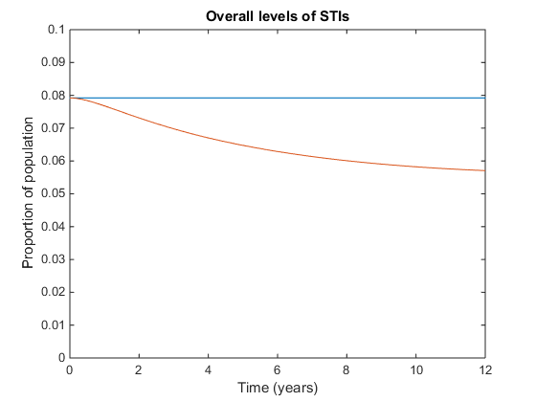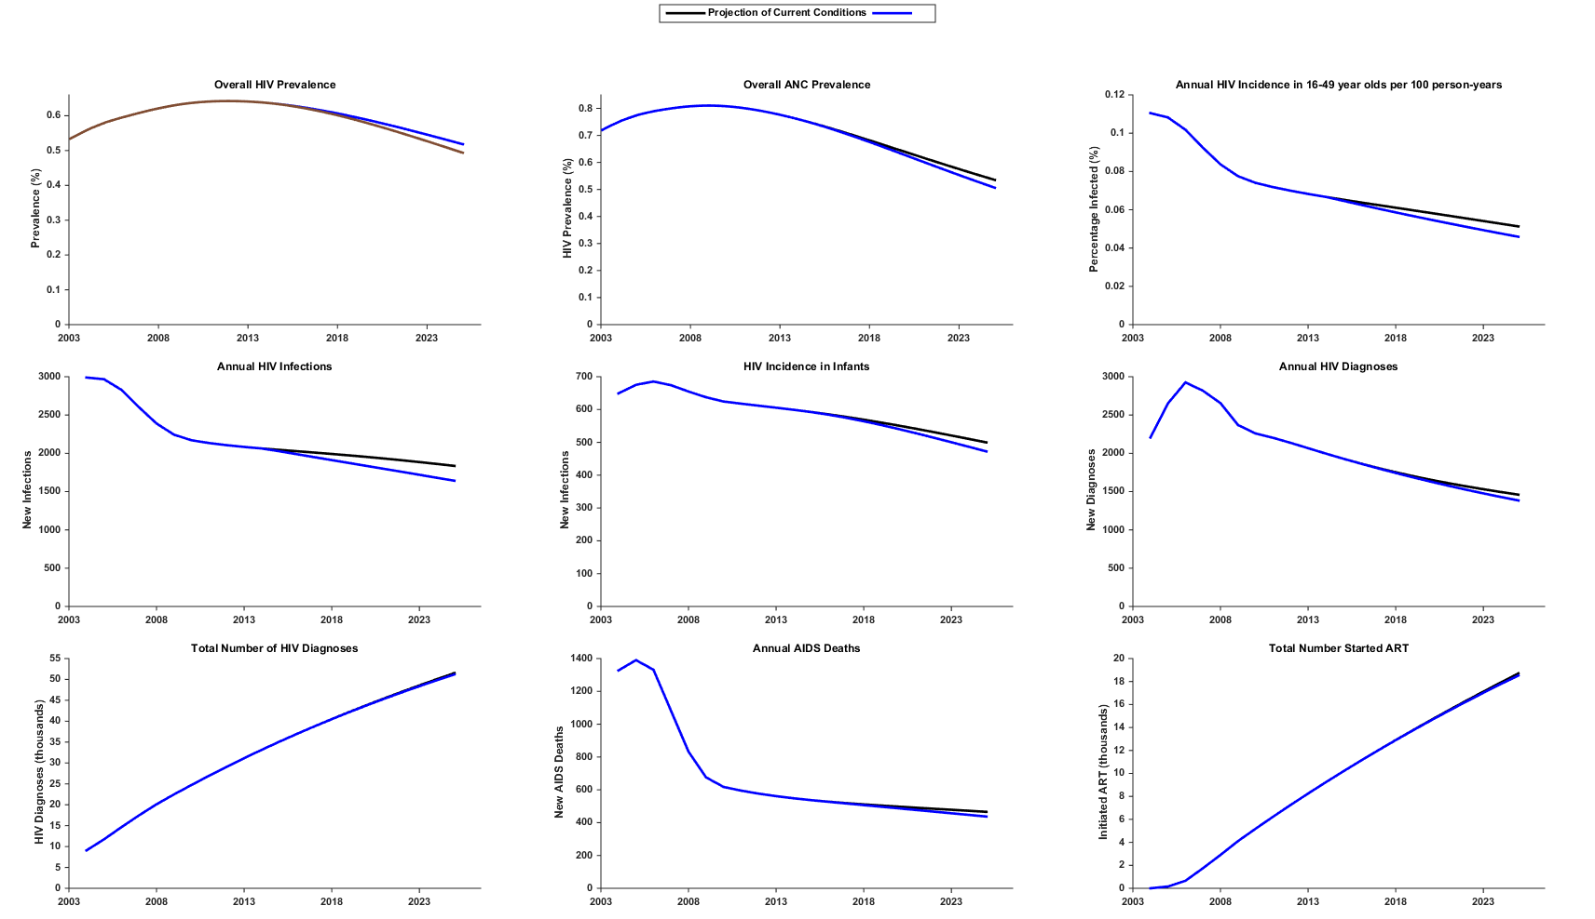

### Choice of sub-population

Providing PPT to general males and females at the same level as to FSW provides a large impact, but this is because there are far more general males and females than FSW. Providing the same number of total treatment doses but distributing these across the whole population results in almost no benefit (0.95% reduction in ulcerating STIs, 0.47% reduction in HIV). Providing PPT to MSMW at the same level as to FSW provides little additional benefit (2% further decrease in ulcerating STIs).

### Varying coverage and number of visits

I will add information here.

## Appendix

### Diagram showing the possible state changes in the model

Diagram 1: The possible states, and possible movements between states over a single period, in our model.

Susceptible

Infected

Resistant

Treatment and loss rate

Infection rate

PPT rate for susceptibles

PPT rate for infected

Move off treatment, and remain susceptible

Move off treatment and be infected immediately

### Description of the parameters in the table

|  |  |  |
| --- | --- | --- |
| Probability of state change (m1) | Description | Footnote |
|  | Infection rate | m1 |
|  | Existing treatment and loss rate | m2 |
|  | PPT rate for susceptible | m3 |
|  | PPT rate for infected | m4 |
|  | Move off PPT, then remain susceptible for one period | m5 |
|  | Move off PPT, then become infected in the same period | m6 |
| m1: We include the term because some people who were susceptible at time immediately receive PPT and enter the resistant group, then later perform sexual acts which would otherwise have infected them. Because these people are now resistant, they do not become infected.  m2: This accounts for all treatment other than PPT, as well as losses and births. Congenital syphilis has a very high mortality rate, and very few people infected at birth survive to enter the sexual population.  m3-m4: Because this only accounts for PPT, which is by definition presumptive, we assume that it is the same for susceptible and infected people. If a person suspects that they might be infected and seeks testing or treatment because of this, we assume that they would have done so anyway, and thus we include it in arrow 2.  m5-m6: We set the time step of our model equal to the duration of protection, so that the entire resistant population from one period becomes susceptible again at the start of the next period. These people have the same probabilities of remaining susceptible or being infected as the already susceptible people, except that we assume they will not receive PPT immediately after they lose their protection, for at least one period. | | |

### Results for all scenariosT:\Crock\SmallModel\Figures\Consequences of extending PPT to all populations.png

An intervention with 75% coverage of the entire population is much more effective than an intervention with 75% coverage of only FSW. However, FSW are only 1.56% of the PNG population, so the former intervention must reach approximately 64 times more people. An intervention which reaches the same number of people, spread evenly across the whole population, would reach only 1.17% of the population, and has a correspondingly much lower impact.

I will add something about providing treatment to the rest of the pop and not to FSWs, and something about holding FSW intervention constant and adding an appropriately small coverage of the rest of the pop.

Expanding an intervention from FSW alone to FSW and MSMW has very little impact on outcomes, yet would still be expensive. I should probably add something where I run an intervention the size of the urban intervention for a rural population.

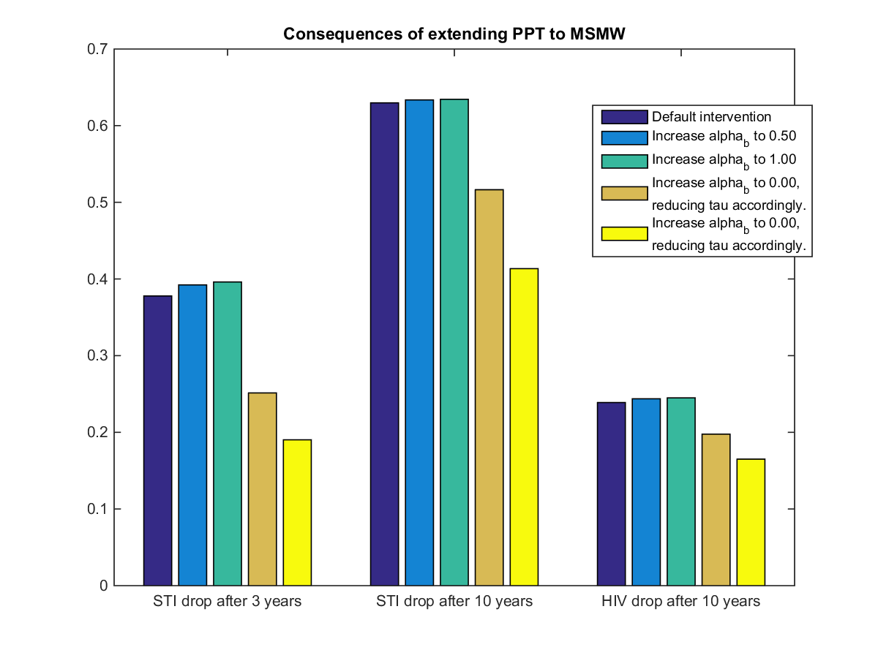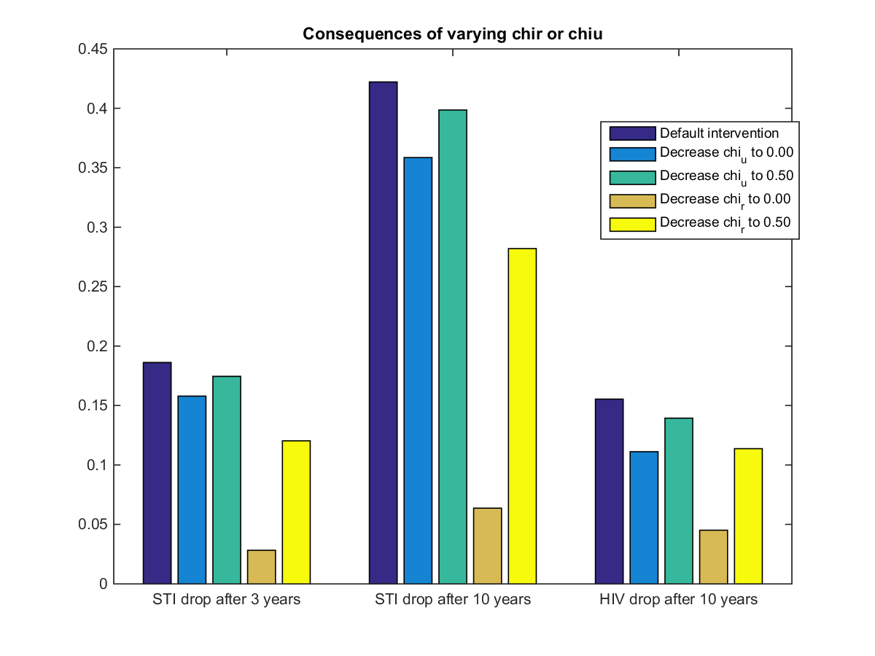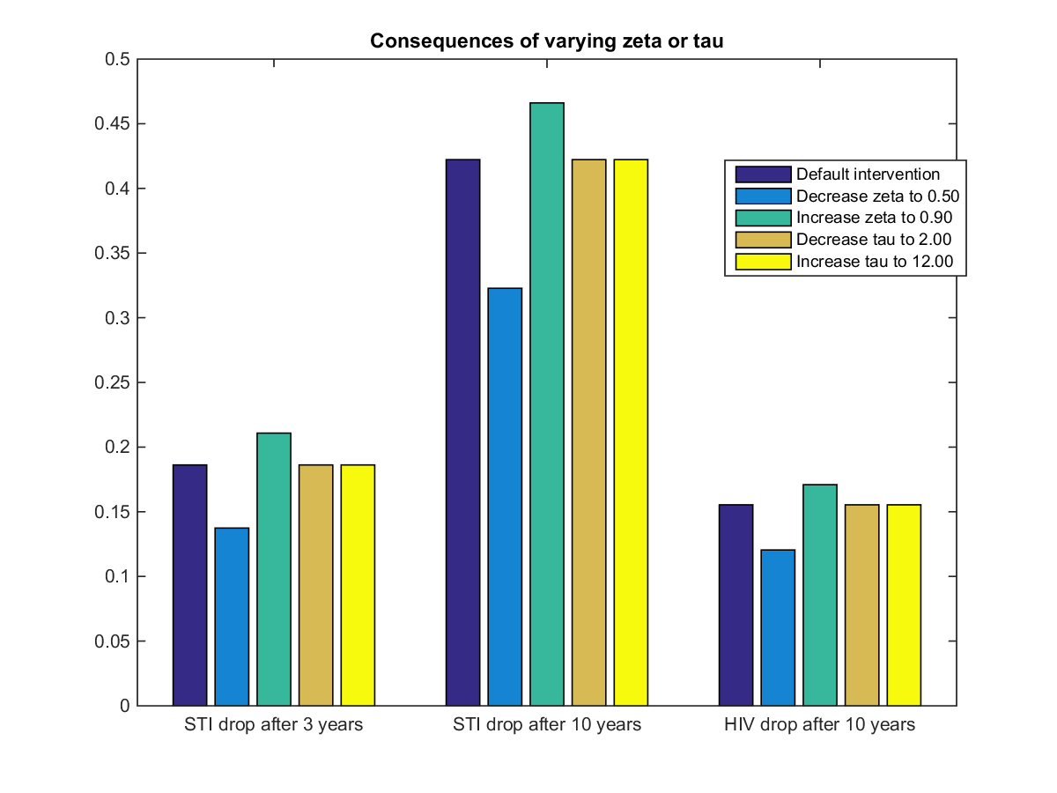

Tau is broken, I should fix it.

I need to fix up the choice of error bounds on my sensitivities.

### Sensitivity analysisT:\Crock\SmallModel\Figures\Sensitivity to gamma and phi.png

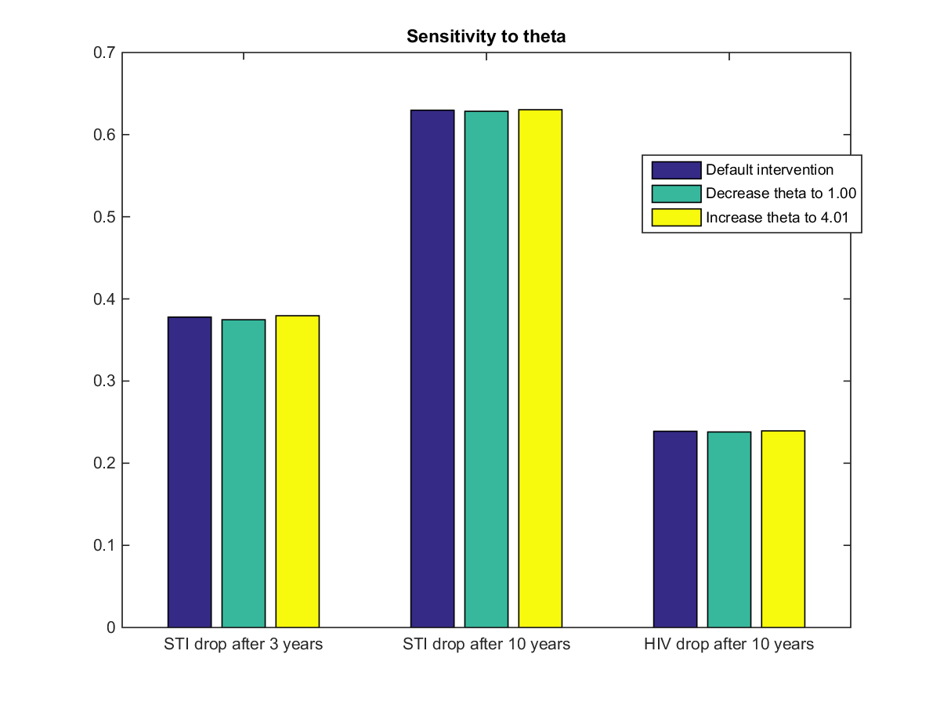

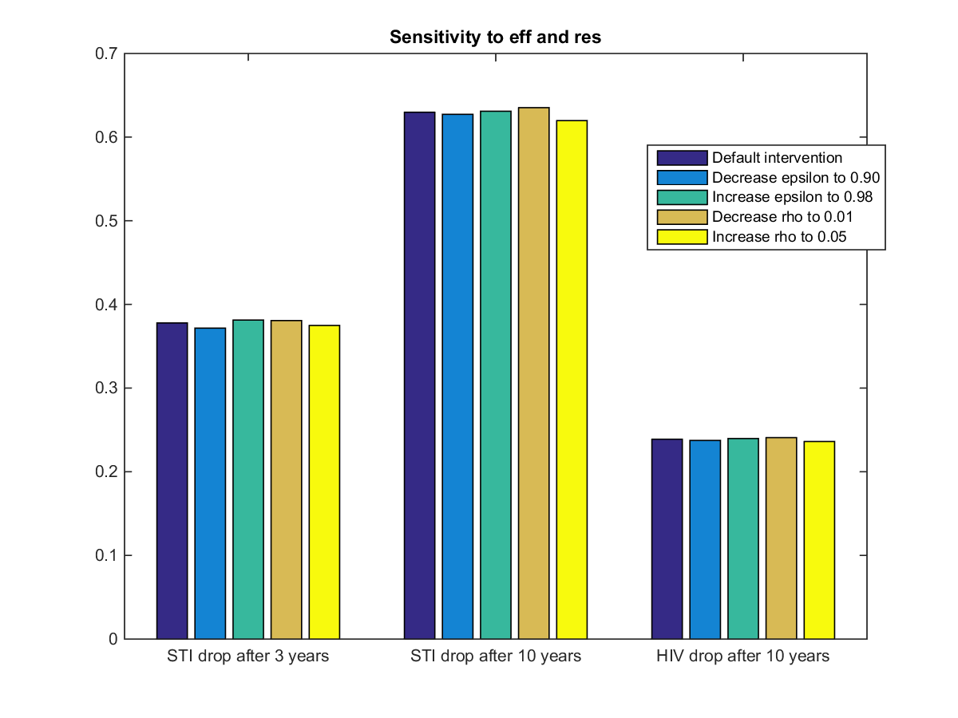

1. We supply values for a rural population one time step into a typical intervention